Lesson 4
How Can I Heal From My Moral Hurt?

Life is full of “living”. Which means life is full of relationships…and people _______ people; life is full of experiences and events…and the circumstances of experiences and events ____ people; and life is full of physical injury, disease and death…these too, ______ people.

- Working definition for Hurt: An experience or event that we believe or perceive to attack us as a person and/or negatively disrupts our life (physically, mentally, or emotionally).
  - Sometimes it may be very serious.
  - Sometimes it may be very petty.
Fact: Either you will gain victory over your hurt or hurt will _____________ you!
Fact: As a believer, you have two choices of how to respond to hurt:
- You may respond to hurt through the works of the ___________.
- You may respond to God each time you encounter hurt by walking after the _____.

- Hebrews 12:15{NT pg. 319} – If you respond to hurt through the works of the flesh, you will inevitably become bitter in life.
  - This will defile _________ life.
  - This will defile the lives of “___________” around you.
  - This will defile every _______________ in your life – with God, your family, your spouse, your children, your church, your work, etc.
- Eph. 4:31{NT pg. 277} – we must see bitterness as sin that needs to be confessed (I John 1:9) and put out of your life.
- (Psalm 37:1-10{OT pg. 759-760}) The cycle of responding to hurt after the works of the flesh.
  - (Vs. 1) “_______” – to cause to heat up or burn; to take it personally within you.
    - To turn the perceived “hurt” into kindling wood that fuels a fire.
  - (Vs. 1) Become ______ – To want that which is not to be yours…at least for now.
    - (Cp. Pr. 24:19{OT pg. 854}) Here is a great irony; we tend to be envious of the wicked and not the righteous.
    - James 4:5-6{NT pg. 324} – envy of anyone is wrong.
    - Envy is rooted in the perception that they have it “better”, “easier”, etc. than we have it…and we believe that we deserve to have it better/easier.
    - The pride behind envy says that we don’t deserve to be hurt!
  - (Vs. 8) “__________” – To have inner turmoil or to boil within our emotions over the hurt itself.
    - The words “fret” and “anger” are closely tied together – fretting is the turning the perceived hurt into firewood and anger is the _______.
    - Anger is the ___________ emotional response because someone or something has either attacked us as a person or has disrupted our life.
    - Anger is an “_____-ward” focus that may result from a perceived hurt.
  - (Vs. 8) “________” – is the Siamese twin to anger in that it seeks to avenge or retaliate for the attack or disruption.
    - Wrath is the “_____-ward” focus that may result from a perceived hurt.
    - Wrath takes the boiling of anger and looks for a way to vent its steam; typically this will be directed at a person (If at all possible. Sometimes the cause of the hurt has no direct connection to a person; however, sooner or later persons will become the recipient of wrath.)
    - Wrath generates the __________, the scheming, and seeking the opportunity for retaliation.
  - (Vs. 8) Do _________ – to behave sinfully in general and/or towards others.
    - Will include sinful and even self-destructive behavior such as sulking, pouting, depression, drugs, alcohol, immorality, etc.
    - May (and frequently does) include malicious and hurtful behavior towards others such as hurtful words, slander, etc. or hurtful physical attacks. Any possible way to inflict hurt on another.

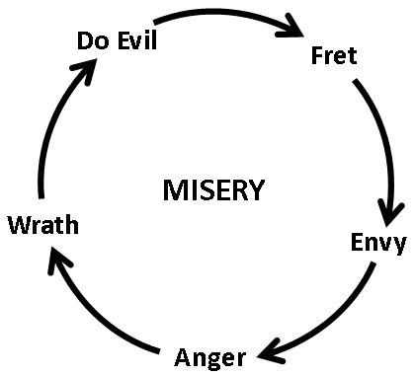

- When we respond to a perceived hurt through the works of the flesh, we discover that the hurt is keenly preserved in the formaldehyde of “bitterness”!
- The result is perpetual misery, self-destruction and a defiling of many.

- Psalm 37{OT pg. 759} also teaches us how to respond to God through our hurt when we walk after the Spirit.
  - (Vs. 2) Understand that evil will be righteously ____________ by God in His providentially appointed time.
  - (Vs. 3) “_________ God”
    - Trust His system and timing of righteous justice.
    - Trust God when He says (Rom. 8:28{NT pg. 226}) that all things are brought/allowed into life for a divine purpose. (Both for the immediate and long term.)
    - Trust God when He says (II Cor. 4:15{NT pg. 258}) that everything that comes into our life including hurt can be used to glorify God.
  - (Vs. 3) Do ________! (As in opposition to doing evil).
    - Responding to perceived hurt after the flesh is one of the biggest reasons Christians stop serving Christ, leave church, etc, and turn to a carnal life.
    - Do “good” by seeking reconciliation…
    - Cp. Rom. 12:17-21{NT pg. 231}; Luke 6:27-36{NT pg. 92}.
  - (Vs. 4) ____________ in the Lord.
(cp. II Cor. 1:1-4{NT pg. 254}; I Pet. 5:7{NT pg. 331})
    - To take joy and thrive in your relationship with God.
    - Hurt will either drive you from God or draw you closer to God. You get the choice of which it will do!
  - (Vs. 5) ____________ thy ways.
    - Commit means to submit or dedicate; submerge your life into i.e. “wallow”. (Think how a hog submerges into a muddy wallow, rolls around in it, completely covers its body, lays down and apparently “joyfully” rests in it.)
    - Submerge the ways of your life into the ways of God.
    - “Ways” = every aspect of your life – attitudes, words, motives, emotions, actions, choices, etc.
  - (Vs. 7) “Rest and wait _______________”
    - This demonstrates our secure feelings in God and with God.
    - To have a confidence and peace in the “workings” of God such that you are not worried or distressed.

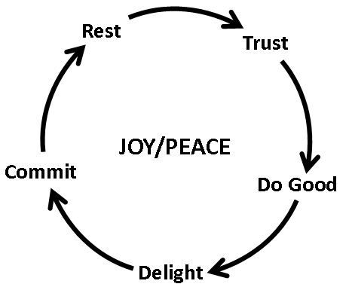
- Now quite frankly these 5 steps are really very simple. Aren’t we glad our God does not make things complicated?
- When you respond to God through your hurt by walking after the Spirit…
  - You will find victory through hurt instead of bondage to your hurt.
  - You will find joy in the Lord through hurt instead of a life of misery.
  - It will be a constructive season in your life instead of destructive.
  - You will be able to strengthen, edify and comfort many instead of defiling many.

